DBKA Membership Renewal Form 2026
Branch | East Devon |  |  |  |  |  |  |  |  |  |  |  |  |  |  |  | Membership Number
Title |  |  |  | First Name |  |  |  |  |  |  |  |  |  |  | Last Name
Email Address |  |  |  |  |  |  |  |  |  |  |  |  |  |  |  |  |  | DoB if under 18
Landline |  |  |  |  |  |  |  |  |  |  | Mobile
Address line 1 |  |  |  |  |  |  |  |  | Address line 2
Address line 3 |  |  |  |  |  |  |  |  | Address line 4
Post Code |  |  |  |  | DBKA Membership Category (2025)
DBKA Membership and fees
 |  |  |  |  | 2026 Membership fee (see table on left) |  |  |  |  |  |  |  |  |  |  |  |  |  |  |  |  |  |  |  |  |  | £
  Registered | £33.00
  Partner | £19.50
  Junior | £8.00
  Local | £6.00
  Honorary | £0.00
 |  |  |  |  | Voluntary contribution to Branch funds |  |  |  |  |  |  |  |  |  |  |  |  |  |  |  |  |  |  |  |  |  | £
 |  |  |  |  | Voluntary contribution to the President's Fund |  |  |  |  |  |  |  |  |  |  |  |  |  |  |  |  |  |  |  |  |  | £
 |  |  |  |  | Other payment (eg course fee, apiary rental fee, etc) |  |  |  |  |  |  |  |  |  |  |  |  |  |  |  |  |  |  |  |  |  | £
Total number of colonies (for BDI purposes) |  |  |  |  |  |  |  |  |  | Extra BDI due, if any (see tables below) |  |  |  |  |  |  |  |  |  |  |  |  |  |  |  |  | £
I wish to subscribe to a printed copy of Beekeeping magazine posted to my home address @£18 |  |  |  |  |  |  |  |  |  |  |  |  |  |  |  |  |  |  |  |  |  |  |  |  |  |  | £
 |  |  |  |  |  |  |  |  |  |  |  |  |  |  |  |  | Total Payment Due
Additional BDI (Registered Members only)
Your total number of colonies | 1-3 | 4-5 | 6-10 | 11-15 | 16-20 | 21-25 | 26-30 | 31-35 | 36-39
Additional Cost | Nil | £1.20 | £4.70 | £7.75 | £9.50 | £11.10 | £13.60 | £16.10 | £18.10

Additional BDI (other categories)
Your total number of colonies | 1-3 | 4-5 | 6-10 | 11-15 | 16-20 | 21-25 | 26-30 | 31-35 | 36-39
Cost | £2.00 | £3.20 | £6.70 | £9.75 | £11.50 | £13.10 | £15.60 | £18.10 | £20.10

GIFT AID DECLARATION: DBKA can claim 25p in Gift Aid for every pound from your membership subscription and donations. Please highlight YES or NO to indicate if you would like DBKA to treat these as Gift Aid donations. To qualify for Gift Aid the payment must be made from your personal account, joint accounts can be used to make payments for both/either account holders where appropriate. - I am a UK taxpayer and understand that if I pay less Income Tax and/or Capital Gains Tax in the current tax year than the amount of Gift Aid claimed on all my donations, it is my responsibility to pay any difference.
 |  |  |  |  |  |  |  |  |  |  |  |  |  |  |  |  |  |  |  |  |  |  |  |  |  |  |  | YES
 |  |  |  |  |  |  |  |  |  |  |  |  |  |  |  |  |  |  |  |  |  |  |  |  |  |  |  | NO
Beekeepers Quarterly Magazine: Please send me the Discount Code for BKQ |  |  |  |  |  |  |  |  |  |  |  |  |  |  |  |  |  |  |  |  |  |  | YES |  | NO
If paying by bank transfer, email a copy of this form to the Branch Treasurer or Membership Secretary |  |  |  |  |  |  |  |  |  |  |  |  |  | Address to send email:  membership@edbk.co.uk
Bank Account Name |  | East Devon Branch - DBKA |  |  |  |  |  |  |  |  | Sort Code |  |  |  |  | 30-90-37 |  |  |  |  | Account No |  |  | 00167584
Send this form with your payment to: |  |  | Memb. Secretary: Val Bone, Charandale, Payhembury, Honiton. EX14 3HZ |  |  |  |  |  |  |  |  |  | Make cheques payable to |  |  |  |  |  |  | East Devon Branch - DBKA
I have read the Notes for Guidance and certify that I meet the requirements for the membership category for which I have applied, and have read and accept the terms detailed in the DBKA privacy statement.
Signed |  |  |  |  |  |  |  |  |  |  |  |  |  |  |  |  | Date

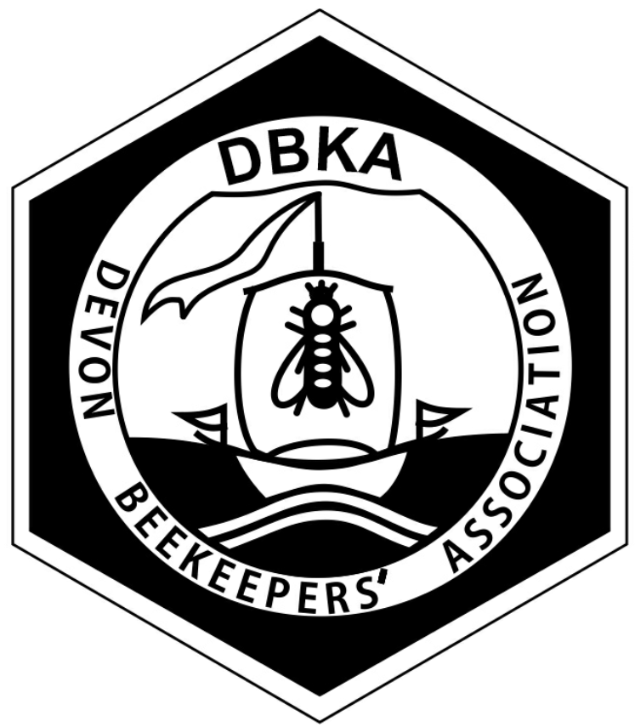
Devon Beekeepers' Association (DBKA)
UK Registered Charity Number 270675
Membership Subscription & Gift Aid
Notes for Guidance

Membership is open to anyone keeping bees or having an interest in the craft of beekeeping. Members of all categories shall be members of a Branch, and members may participate in the activities of any Branch of DBKA. Membership renewal/subscription may be completed via the BBKA eReturn2 On-line Membership facility.
The membership year starts on 1st January and ends on 31st December.
The annual subscription for all existing members renewing their subscription is payable in advance of 31 December. Members are not entitled to the benefits of the DBKA until their subscription has been paid.
Bee Diseases Insurance (BDI) cover is subject to BDI Regulations. (See page 3.)
Gift Aid Declaration
DBKA can claim 25p in Gift Aid for every pound from your membership subscriptions and donations. Please enter YES in the Gift Aid Section of the Online form to indicate that you would like DBKA to treat all membership subscriptions and donations as Gift Aid donations.
To qualify for Gift Aid the payment must be made from your personal account, joint accounts can be used to make payments for both/either account holders where appropriate.
You are confirming that you are a UK taxpayer and understand that if you pay less Income Tax and/or Capital Gains Tax in the current tax year than the amount of Gift Aid claimed on all your donations, it is your responsibility to pay any difference.

Membership Classes:
- Registered Member - for those individuals who keep bees in their own right and wish to take a full part in all the aspects of the DBKA.
- Partner Member - for those individuals who reside at the same address as a Registered Member.
- Junior Member - for individuals under the age of 18 years. Junior membership shall cease when the individual attains the age of 18 and shall be automatically and immediately amended to Registered Membership for the remainder of that membership year, without further payment.
- DBKA Honorary Member - for those individuals who are elected at a DBKA AGM, either for a limited period or for life, in recognition of past services to beekeeping and the DBKA. The subscription is payable by the DBKA and the Honorary Member shall enjoy the same benefits as a member in the same membership category to which the member subscribed before being elected an Honorary Member.
- Branch Honorary Member - for those individuals who are elected at a Branch AGM, either for a limited period or for life, in recognition of past services to beekeeping and the Branch. The subscription is payable by the Branch and the Honorary Member shall enjoy the same benefits as a member in the same membership category to which the member subscribed before being elected an Honorary Member.
- Local Member - for those individuals who do not keep bees in their own right in the County of Devon, who are generally interested in the craft of beekeeping and may wish to participate in DBKA activities, belong to a Branch, and receive Beekeeping Magazine, or are already a BBKA member with another Area Association.
- Schools/Educational Establishments Member - for those schools and educational establishments who wish to keep bees in their own right and wish to take a full part in all aspects of the DBKA.
- Corporate Member - for commercial and academic bodies or organisations that wish to support, in whole or part, the work of the DBKA.

(For further information on categories please consult your Branch Membership Secretary or read the current DBKA Governing Document.)
Registered, Partner, Junior and Schools/Educational members have BBKA membership, and names and addresses will go on the list of registered members held by BBKA.
DBKA Membership Classes Benefits
Benefit  Class of  Membership¹ | General Meetings | 3rd Party Liability & Product Insurance | Bee Diseases Insurance (BDI)² | BBKA News and  other direct communications | Access to BBKA ‘Members Only’ Website Section | Access to DBKA ‘Members Only’ Website Section | Events and Advice | Representation and Facilities | DBKA Members' Directory | Officer Eligibility | Committee Eligibility
Registered⁴ | A,P S,V | Y | Y | Y | Y | Y | Y | Y | Y | Y | Y
Partner⁴ | A,P S,V | Y | N³ | N | Y | Y | Y | Y | Y | Y | Y
Junior⁴ | A,S | Y | N³ | Y | Y | Y | Y | Y | Y | N | Na
Local⁵ | A,S | N | N | N | N | Y | Y | Y | Y | N | N
Honorary | Benefits are the same as the class of membership the member enjoyed  prior to becoming an Honorary Member
Corporate | None

Notes: A - the right to attend P - the right to submit propositions for consideration
S - the right to speak V - the right to vote
¹ The membership year for all members is defined as the 12 calendar months commencing on 1 January each year.
² Additional option for Junior Members who are over 16 and Partner Members if required.
³ Unless the Junior (over 16) or Partner Member keeps bees in their own right and pays the appropriate BDI fee.
⁴ Registered, Partner (if taken), and Junior (if taken) Members insurance cover begins as soon as they have paid and received a receipt for their subscription.* All other benefits for Registered, Partner, Junior and Schools/Educational Members begin when their registration details have been received by BBKA.
(* Unless payment is made after 31 March, in which case it takes 40 days for the BDI insurance cover to become effective.)
⁵ Local Members will not have any honey bee colonies of their own in the County of Devon, but if they take up beekeeping in their own name or take up an official post at County level then they shall take up either Registered or Partner membership.
⁶ Schools/Educational Members will also have on-line access to the “Bees in the Curriculum” area of the BBKA website, and access to the Junior Assessment without charge.

Beekeeping Magazine

All paid-up members of DBKA will receive a digital link to Beekeeping magazine - 10 issues per year. In addition, members may opt to receive a printed copy delivered through the post to their home address for an additional cost of £18.

DBKA President’s Fund
The Devon Beekeepers’ Association President’s ‘Foundation’ Fund provides a grants programme to organisations to promote and further the craft of beekeeping and to advance the education of the public in the importance of bees in the environment.
The Beekeepers Quarterly is a quality beekeeping journal for beekeepers interested in what is happening around the world. It is produced four times a year (March, June, September, December). DBKA members are eligible for a discounted subscription. The discount code can be obtained from your Branch Secretary.

Notes to help you complete the DBKA Membership Renewal form
Bee Diseases Insurance (through BDI Ltd) covers losses due to notifiable bee diseases. Insurance for three colonies is included in Registered Members' subscription only. Registered Members with more than 3 hives are required to increase the insurance component of their subscription as per the table below. Partner Members are not required to make any BDI payment, but the Registered Member is responsible for insuring all colonies owned by themselves and their Partner Member. Bees kept by Junior Members whose parents do not keep bees, or who have not insured the Juniors’ bees on their behalf can have insurance taken out on their behalf with BDI. In such circumstances the paper or e-Return receipt should show the Junior member’s name in the usual way, but the first line of the address should be replaced by - 'Mr A Adult (on behalf of J Junior)', followed by the address on the remaining lines. (Beekeepers under the age of 16 years are unable to take out insurance policies and any policy has to be arranged by a parent or guardian.) Members are advised to read the terms and conditions of this insurance before subscribing to ensure that the cover and terms are appropriate for their situation. Use the tables below to calculate the premiums payable. Special terms are available for members with forty or more colonies.

Registered Member
Your total  number of hives | 1-3 | 4-5 | 6-10 | 11-15 | 16-20 | 21-25 | 26-30 | 31-35 | 36-39
Additional Cost | Nil | £1.20 | £4.70 | £7.75 | £9.50 | £11.10 | £13.60 | £16.10 | £18.10
(Example -if you have 4 hives in total, the first 3 are covered in the subscription. You need to pay a further £1.20.)

Partner and Junior Member
Your total  number of hives | 1-3 | 4-5 | 6-10 | 11-15 | 16-20 | 21-25 | 26-30 | 31-35 | 36-39
Cost | £2.00 | £3.20 | £6.70 | £9.75 | £11.50 | £13.10 | £15.60 | £18.10 | £20.10

DBKA Privacy Statement
Data Protection
The General Data Protection Regulation (GDPR) means that we need your consent to hold your details and to contact you. We will only contact you from time to time with newsletters and news updates relevant to DBKA at large, and to notify you of DBKA, BBKA, and other beekeeping associations’ related events. We will take all reasonable steps to keep your details safe and we will not pass your details on to any other organisation without your explicit consent. The only exceptions to that will be to the associations/agencies required as part of your membership process. Your data is only kept by us while you remain a DBKA member and for a period of one month after your membership lapses to provide you with a chance to renew your existing membership. We may, however, retain data for differing periods of time for different purposes as required by statute or best practices. All DBKA members are free to update their details stored with us at any time through your Branch Membership Secretary.

Your rights
You have the right to request:
- Your contact details are not published in the DBKA Member Directory
Such request should be made directly to your Branch Membership Secretary.
BeeBase
BeeBase is a valuable beekeeping resource maintained by the National Bee Unit (NBU). In addition to providing information to beekeepers, it maintains a voluntary register of beekeepers in England, Wales and Scotland.
By responding "Yes" to the BeeBase question you agree to share the following data with the National Bee Unit BeeBase system for the purpose of disease monitoring and control: Name, Address, Email, Telephone/Mobile, Membership Number and the name of the Association of which you are a member.

